1 Data extraction and processing
As introduced in the background section, the case study relies on two public databases in Denmark, the Smiley database and the CVR database. The data used in this study were extracted in March 2025, resulting in a dataset of 52,529 FBOs after matching the data from the two databases (among 128,564 FBOs from Smiley data). Later downloads may differ since both datasets are updated continuously. The original Smiley and CVR datasets, as well as the merged new dataset are provided as Supplementary Materials S0.
From the Smiley database, we extracted up to four most recent inspection results and their corresponding dates, company identifiers (cvr_number and name), and FBO characteristics (type and industry). Inspection results are expressed as numeric scores from 1 (best compliance) to 4 (worst compliance), which we interpret as ordered compliance levels.
It is important to note that the cvr_number is the unique legal identifier assigned to each company in Denmark (Erhvervsstyrelsen, 2025). A single cvr_number may correspond to multiple physical establishments, each listed under a distinct name in the Smiley database. Therefore, FBOs sharing the same cvr_number were interpreted as chain FBOs in this research. FBOs with only one unique cvr number were categorized as non-chain FBOs.
For each inspection record, we retrieved the most valid value for the number of employees according to the inspection dates. However, The CVR database stores this information at the company level (per cvr_number), not separately for each establishment. Consequently, for chain FBOs, the reported employee number represents the total sum of all establishments under the same cvr_number. To ensure comparability between chain and non-chain FBOs, we evenly distributed the value across all establishments sharing the same cvr_number, assuming that employees are approximately evenly distributed among chain units.
Capital information was also extracted from the CVR database. However, due to extensive missing values, it was excluded from subsequent analyses.
Both databases are maintained in Danish, and therefore all variable names and categorical labels were translated into English for analysis with DeepL. Original codes were preserved in the raw dataset to ensure reproducibility. Table 1 lists the variables extracted from each database and their definitions.
Table 1 Extracted variables
Variable (English) | Raw name (Danish) | Description | Example values | Source
cvr_number | cvrnr | Unique company identifier assigned by the Danish Business Authority (used to link FBOs across datasets) | e.g., 12345678 | Smiley database
name | navn1 | Registered name of individual FBO | e.g., Café xxx | Smiley database
Industry | branche | Industry classification describing the main product or activity of the FBO | e.g., Specialty store - Baker etc. | Smiley database
FBO type | virksomhedstype | Whether the FBO operates as retail (detail) or wholesale (engros) | Retail; Wholesaler | Smiley database
Operation type | derived from cvrnr | Whether the FBO belongs to a chain (repeated cvr number) or is independent (unique cvr number) | Chain;  Non-chain | Smiley database
latest_inspection | seneste_kontrol | Result of the most recent inspection, expressed as numeric score from 1 (best) to 4 (worst) | 1, 2, 3, 4 | Smiley database
second_latest_inspection | naestseneste_kontrol | Result of the second most recent inspection | 1, 2, 3, 4 | Smiley database
third_latest_inspection | tredjeseneste_kontrol | Result of the third most recent inspection | 1, 2, 3, 4 | Smiley database
fourth_latest_inspection | fjerdeseneste_kontrol | Result of the fourth most recent inspection | 1, 2, 3, 4 | Smiley database
Inspection dates (correspond to inspection results) | seneste_kontrol_dato, naestseneste_kontrol_dato, tredjeseneste_kontrol_dato, fjerdeseneste_kontrol_dato | Dates of each inspection results | e.g., 2019-06-30 | Smiley database
Number of employees  (correspond to inspection dates) | nr_employees | Number of employees of each FBO | e.g., 338 | CVR database

In addition to the extracted variables, several new variables were derived to better represent the risk factors of FBOs relevant for modelling.
First, FBO size was derived from the number of employees. Company size is frequently considered a risk factor in risk-based food safety inspections (van Asselt et al., 2021). Larger FBOs may have better safety management systems and resources, while smaller businesses may face constraints. Across countries, FBO size has been measured in various ways, including number of employees, production volume, or physical area (Ze et al., 2024, 2025). In this study, only the number of employees was available and therefore used as a proxy for FBO size. The values were categorized into ordered groups following the European Commission’s definition of micro, small and medium enterprises (European Commission, 2003), with minor adjustments to cover the whole range of Danish FBOs. The classification scheme is presented in Table 2.
Table 2 Adapted FBO size classification scheme
FBO size | Number of employees | Adjustment to EU scheme
Small | 0-9 | Merged EU classes (a) and (b)
Medium | 10-49 | Same as EU class (c)
Large | 50-249 | Same as EU class (d)
Extra Large | ≥ 250 | New category added for range beyond EU scheme

Second, the industry variable was translated and regrouped into a simplified variable name as product type to represent the type of food handled or sold by each FBO. The original variable contained over seventy categories, but after data cleaning described in Section 1, fifty five categories remained eligible for regrouping. To make the data compatible with European frameworks, these categories were regrouped into eight broader product type categories, guided by a summarized EU food classification code book (FASI, 2021). The code book is provided as Supplementary Materials S4. The original name and translation of categories as well as the new groups and relevant codes are summarized in Table 3.
Table 3 Regrouping of Industry to product type
Industry (Danish) | Industry (English) | Product type | EU codes
Fremstilling af animalske produkter - Mælk og ost | Manufacture of animal products - Milk and cheese | Animal-based product | 01-04
Fremstilling af animalske produkter - Æg | Manufacture of animal products - Eggs | Animal-based product | 01-04
Fremstilling af animalske produkter - Kød | Manufacture of animal products - Meat | Animal-based product | 01-04
Slagtebusser | Slaughter buses | Animal-based product | 01-04
Slagterier | Slaughterhouses | Animal-based product | 01-04
Specialforretning - Slagter m.v. | Specialty store - Butcher etc. | Animal-based product | 01-04
Fremstilling af animalske produkter - Fisk og muslinger m.v. | Manufacture of animal products - Fish and mussels, etc. | Animal-based product | 01-04
Håndtering af levende toskallede bløddyr | Handling of live bivalve molluscs | Animal-based product | 01-04
Specialforretning - Fisk m.v. | Specialty business - Fish, etc. | Animal-based product | 01-04
Fremstilling af animalske produkter - Andre produkter | Manufacture of animal products - Other products | Animal-based product | 01-04
Frysehuse med indfrysning af animalske produkter | Freezers with freezing of animal products | Animal-based product | 01-04
Specialforretning - Bager m.v. | Specialty business - Baker, etc. | Plant-based product | 07-08, 15
Virksomhed, foreløbig: Bagerforretning, bagerafdeling, kondi | Business, provisional: Bakery, bakery department, condiment | Plant-based product | 07-08, 15
Virksomhed, foreløbig: Fremstill. af bagværk, brød, pasta o. | Business, provisional: Manufacture of baked goods, bread, pasta etc. | Plant-based product | 07-08, 15
Virksomhed, foreløbig: Fremstill. af prod. sammensat af fora | Business, provisional: Manufacture of products composed of fora | Plant-based product | 07-08, 15
Fremstilling af vegetabilske produkter mv. evt. med indhold | Manufacture of vegetable products, etc. possibly with content | Plant-based product | 07-08, 15
Virksomhed, foreløbig: Fremstill./pakn. af konfekture, sukke | Business, provisional: Manufacture/packaging of confectionery, sugar | Plant-based product | 07-08, 15
Fremstilling af drikkevarer m.v. | Manufacture of beverages, etc. | Beverages | 10-12
Virksomhed, foreløbig: Servering, fx værtshus, vinbar, autom | Business, provisional: Serving, e.g. tavern, wine bar, vending | Beverages | 10-12
Virksomhed, foreløbig: Fremstill./pakn. af drikkev., maltfab | Business, provisional: Manufacture/packaging of beverages, malt fab | Beverages | 10-12
Fremstilling af kosttilskud, tilsætningsstoffer m.v. | Manufacture of dietary supplements, additives, etc. | Dietary Supplements & Additives | 18-19
Fremstilling af fødevarekontaktmaterialer, detail | Manufacture of food contact materials, retail | Materials and Articles Intended to come into Contact with Foodstuffs | 20
Fremstilling af fødevarekontaktmaterialer, engros | Manufacture of food contact materials, wholesale |  | 20
Markedsføring af fødevarekontaktmaterialer, detail | Marketing of food contact materials, retail |  | 20
Markedsføring af fødevarekontaktmaterialer, engros | Marketing of food contact materials, wholesale |  | 20
Catering med levering til detailvirksomheder (detail med eng | Catering with delivery to retail establishments (retail with eng) | Mixed Food - with processing
Serveringsvirksomhed - Institutionskøkkener m.v. | Serving business - Institutional kitchens, etc. | Mixed Food - with processing
Serveringsvirksomhed - Restauranter m.v. | Serving business - Restaurants, etc. | Mixed Food - with processing
Specialforretning - Delikatesse, specialiteter m.v. med beha | Specialty business - Delicatessen, specialties, etc. with treatment | Mixed Food - with processing | 17 & 21
Virksomhed, foreløbig: Institutionskøkken, fx børneinstituti | Business, provisional: Institutional kitchen, e.g. children's institution | Mixed Food - with processing
Virksomhed, foreløbig: Restaurant, pizzeria, cafe, kantine | Business, provisional: Restaurant, pizzeria, cafe, canteen | Mixed Food - with processing
Virksomhed, foreløbig: Smørrebrødsforr., delikatesseafd., ta | Business, provisional: Sandwich shop, delicatessen, ta | Mixed Food - with processing
Dagligvareforretning uden/med begrænset behandling | Grocery store without/with limited processing | Mixed Food
Lager og evt. engroshandel med salg til detailvirksomheder ( | Warehouses and possibly wholesale trade with sales to retail establishments | Mixed Food | 17&21
Lager/lagerhotel og evt. engroshandel - Med køl/frost | Warehouse/warehouse hotel and possibly wholesale trade - With refrigeration/freezing | Mixed Food
Lager/lagerhotel og evt. engroshandel - Uden køl/frost | Warehouse/warehouse hotel and possibly wholesale - Without refrigeration/freezing | Mixed Food
Serveringsvirksomhed - Uden behandling | Serving business - Without treatment | Mixed Food
Transportvirksomhed, detail | Transport business, retail | Mixed Food
Transportvirksomhed, engros | Transport business, wholesale | Mixed Food
Virksomhed, foreløbig: Butikshandel, fx dagligvareforr., grø | Business, provisional: Retail trade, e.g. grocery store, green | Mixed Food
Virksomhed, foreløbig: Butikshandel, fx kiosk, apotek, helse | Business, provisional: Retail trade, e.g. kiosk, pharmacy, health | Mixed Food
Virksomhed, foreløbig: Detailforr. m. beh., fx mikrobryggeri | Business, provisional: Retail trade, e.g. m. processing, e.g. microbrewery | Mixed Food
Virksomhed, foreløbig: Engroshandel og/eller lager/lagerhote | Business, provisional: Wholesale trade and/or warehouse/warehouse | Mixed Food
Virksomhed, foreløbig: Internethandel, mobil virksomhed (fx | Business, provisional: Internet trade, mobile business (e.g.) | Mixed Food
Virksomhed, foreløbig: Internethandel, udelukkende salg og m | Business, provisional: Internet trade, exclusively sales and m | Mixed Food
Virksomhed, foreløbig: Mobil virksomh.(fx salg af br. mandl. | Business, provisional: Mobile business (e.g. sale of br. mandl.) | Mixed Food
Virksomhed, foreløbig: Transportvirksomhed, detail, ikke-let | Business, provisional: Transport business, retail, non-light | Mixed Food
Virksomhed, foreløbig: Transportvirksomhed, detail, letfordæ | Business, provisional: Transport business, retail, light consumption | Mixed Food
Virksomhed, foreløbig: Transportvirksomhed, engros | Business, provisional: Transport business, wholesale | Mixed Food
Kædekontrolhovedkontor - Fødevarer | Chain control headquarters - Food | Office
Kontorvirksomhed eller agenturvirksomhed - uden lager | Office business or agency business - without warehouse | Office
Midlertidig ejerskifte-branche | Temporary change of ownership sector | Office | 21
Virksomhed, foreløbig: Kontorvirksomhed (fødevarer og/eller | Business, provisional: Office business (food and/or) | Office
Virksomhed, foreløbig: Kontorvirksomhed, uden køl/frost, me | Business, provisional: Office business, without refrigeration/freezing, me | Office

Finally, an inspection interval variable was constructed to represent the number of days between two consecutive inspections of the same FBO.
2 Data cleaning and imputing
Handling missing data was a crucial step to ensure the quality and consistency of the merged dataset. Two key variables contained missing values, namely, FBO size (derived from the number of employees) and inspection results. These issues were addressed sequentially as described below.
The number of employees in the CVR database is updated periodically, and its valid periods do not always align with the inspection dates, leading to missing values. For modelling purposes, the number of employees was mapped to FBO size categories, as defined in Section 3.2. The completeness and internal consistency of FBO size information within each FBO are summarized in Table 4. It summarizes the number of FBOs with available employee data for 0-4 inspection records, and distinguishes between those with consistent and inconsistent reported FBO sizes. Inconsistent cases refer to FBOs where the reported number of employees changed significantly that their FBO size shifted into different categories between inspections.
Table 4 Completeness and consistency of FBO size data before imputation
Number of filled FBO size | Number of FBOs | Consistent FBO size | Inconsistent FBO size
0 | 14657 | - | -
1 | 3560 | - | -
2 | 2455 | 2386 | 69
3 | 1989 | 1903 | 86
4 | 29868 | 28859 | 1009
Total | 52529 | 33148 | 1164

Overall, 56.9% of FBOs had valid FBO size information for all four inspection dates, 27.9% had no available data, and the remaining 15.2% had partially missing records (1-3 values available). FBOs with no available employee data were removed from the dataset, as FBO size is considered as a key variable that impacts food safety risk.
For FBOs with partially missing records for employee counts, missing values for FBO size were imputed using a nearest-in-time approach. Specifically, we applied a forward-fill and backward-fill strategy, propagating the last known value forward or the next known value backward, ensuring that every FBO left has all times FBO size value. This approach assumes that FBO size changes gradually, which is reasonable as most FBOs remained consistent in FBO size across their inspection records.
After applying this imputation and removing FBOs with no FBO size data, 37872 (72.1%) FBOs remained in the dataset, each with complete FBO size data across all available inspection results.
Based on the cleaned dataset, we then examined the completeness of inspection records. The Smiley database provides up to four historical inspection results for each FBO. However, not all FBOs had all four inspection records available. Figure 1 illustrates the distribution of FBOs by the number of available inspection results in the dataset after FBO size cleaning.
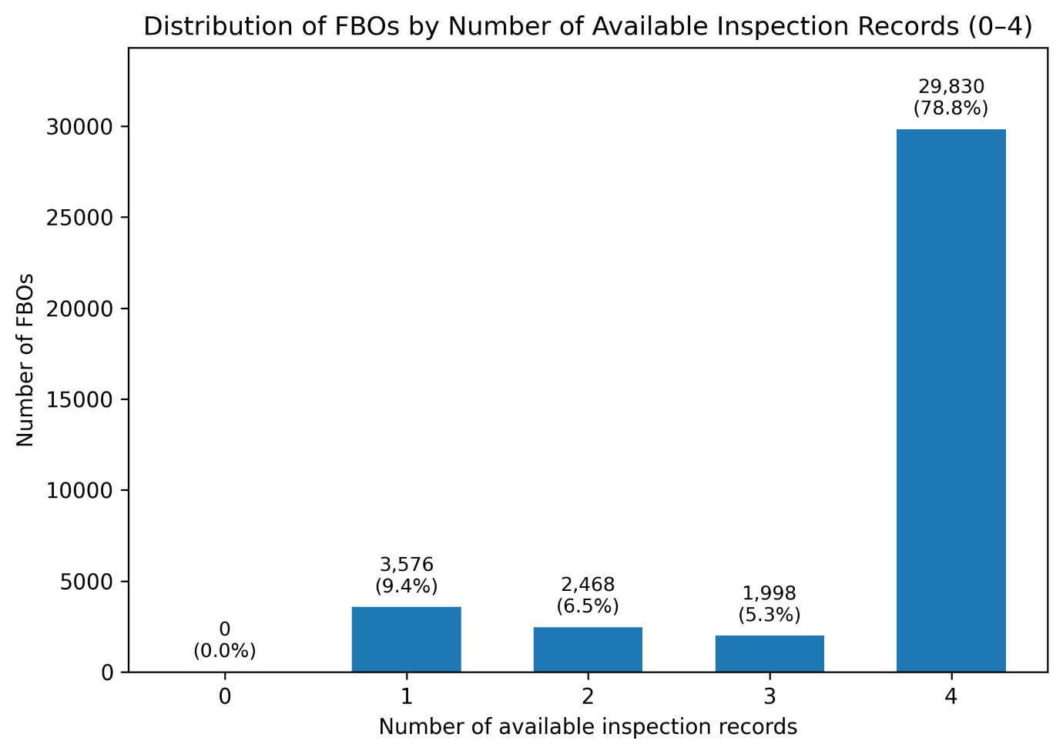
Figure 1 Distribution of FBOs by the number of available inspection results
Most FBOs had full four times of inspection results, but 9.4% of FBOs had only one inspection result available. Considering the aim of the machine learning model, to predict the compliance behaviour changes of FBOs, at least two inspection results are required to calculate such changes. Therefore, FBOs with fewer than two inspection records were excluded from further analysis. After this filtering, the dataset retained 34296 FBOs, each with two to four historical inspection results.
FBOs with multiple inspection results were further decomposed into separate data entries with paired inspection results, each representing a transition between two inspections. For instance, an FBO with four inspections (1st–4th) was split into three pairs, (1st–2nd), (2nd–3rd), and (3rd–4th). The earlier inspection in each pair was named as the former inspection result, and the later inspection as the latter inspection result. This yielded a total of 41,552 valid data entries.
From this transformed dataset, two new variables were then derived to support subsequent modelling. Behaviour change is calculated as the difference between the latter and former inspection results. The values range from –3 to +3 ( -3; -2; -1; 0; 1; 2; 3), where negative values indicate improvement in compliance, positive values indicate deterioration, and 0 indicates no change.

